The SU Feedback tool report

Week beginning 30th March

This report shows the feedback and analysis of both Exeter and Falmouth Universities (including their collaborative partnerships) and is a working document to show the ever-changing views, feelings and opinions of our members during this time of remote working due to the COVD-19 pandemic. These reports will be produced weekly in order to support both the SU, the Sabbatical Officers and both Universities. Quotes from students are emboldened throughout the report.
A total of 328 students filled out our feedback tool, 81% of these respondents where Falmouth Students. Departments with the highest number of respondents where: Games Academy, Falmouth School of Art, School of Film and Television, Academy of Music and Theatre Arts.

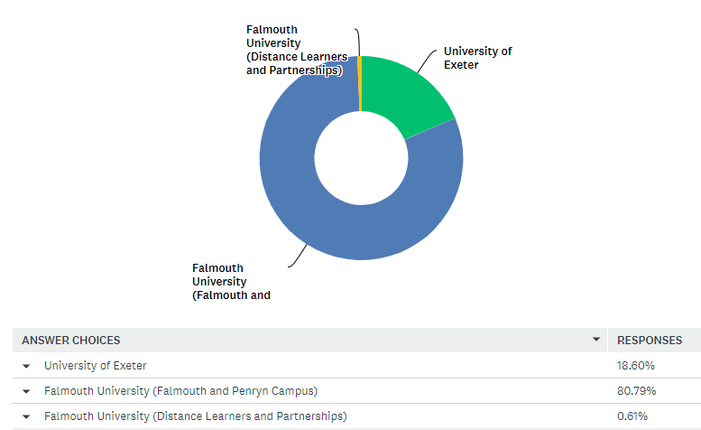
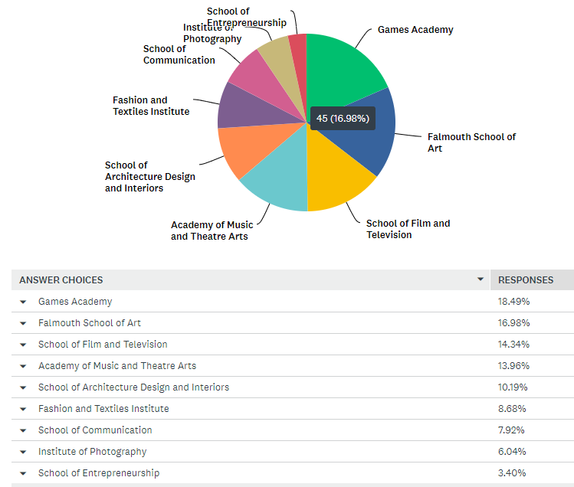

Daily Trends

Tuesday 31st
On the first day of launching the feedback tool to the wider student population there were a considerable number of concerns raised by International/EU students trying to understand how this will affect them in terms of submissions, and of accessing online lectures whilst being in a significantly different time zone. There were also an equal number of concerns raised regarding the lack of clarity from Falmouth University regarding assessments and how students, particularly in the art-based subjects would have to adapt their process and submission, without being provided clear guidelines on expectations. There were also some initial concerns on employability at the end of the course with several 3rd year students concerned about their future and a loss of potential job opportunities.
April 1st
The feedback from students shifted towards the ability to work home for a sustained period and how to manage it. Some students wanted regular and clear support on how to manage it, however most feedback was about the lack of equipment such as printers, specialist software, poor internet connection and physical resources. As one student stated “As third year students we are expected to produce the same amount and quality of work for the limited time that we have regardless of these circumstances. We have also been introduced to things that are difficult to comprehend at this time in terms of teaching. I believe that all of this will not be helpful when we are producing our portfolios. I wish that we had extra time to finish our work and make up for the lost week of not knowing what is happening.” A tier 4 international student was also keen to point out that there are concerns for those students as the need to be ‘checked off’ each week by a staff member to make sure they are attending university became increasingly more challenging.
April 2nd
There was a variation in the type of feedback from Thursday’s feedback, however the most commonly occurring feedback was the concern of their won and others mental health moving forward, which in turn could lead to a lack of motivation. This would be worrying due to the critical time period with projects and work due with one student suggesting that “Falmouth University may need to release some communications both supporting students but also a ‘safety net’ offer like other universities.” Several feedback forms showed that students wanted extensions in order to create the best possible work they can whilst adapting to their new working systems. Individual concerns are coming to the fore, with a student raising an issue about their lack of accommodation within private renting. Some positives were flagged by students in response to home working, particularly the ability to remote control computers in the studio.

April 3rd
The number of responses normalised after the initial three-day surge, but international students were regular contributors to the feedback tool, highlighting the issues that are faced with working in a different time zone. The student stated that questions were not being answered quickly from his lecturer during a time critical period due to the time difference and that was concern. Issues with software, teamwork and remote working were all raised with a student stating that:
“We have teammates unable to work on the projects, because of lack of equipment that should've been supplied by the university, yet the deadlines remain the same.”
April 4th
International Students are providing most of the feedback on Saturday and Sunday, highlighting their concerns about family members in home countries suffering from COVD-19 and not being able to focus on work/lectures. The feedback provided by International Students is looked at more detail later in the report.

Top Themes Analysis
The main points from the first week of the feedback tool quite clearly show that the main four concerns, if ‘other’ is not included for being too general, are:
- Health and Wellbeing
- Teaching on my course
- Access to Resources
- Employability
The SU has now established its welfare and advice service online and is supporting in its capacity, but FX Plus and its senior staff, particularly in the area of health and Wellbeing need to be aware of the numbers of students logging it as their main concern at this moment in time. Some statements from Students regarding health and wellbeing on the feedback tool include:
Health and Wellbeing
This is understandably the main concern for students during this time, and there is a clear association between the pandemic, deadlines and anxiety leading to health concerns in both a physical and mental capacity. These statements from the feedback tool highlight some of the general worries’ students are having:
“I am having a lot of anxiety about my health, as COVID-19 poses a legitimate concern to me because of my asthma. If I look at it logically, there is a very real possibility that if i catch it - it would kill me. This is making it hard for me to focus on my work”.
Teaching on my course
There have been a number of positive feedback statements left on the SU feedback tool which highlight the good work that departments are doing in order to adapt to the demands of online or remote working such as the feedback below:
“The games academy has done a spectacular job at moving the courses online and allowing all students remote access to the warehouse PC's so that no student is at a disadvantage due to our course being very hardware and software heavy. The tech team has been amazing, providing us with videos of tutorials, always being available, responding within minutes. Teaching has also been very good. Using Microsoft Teams has allowed us to share our screens between the lecture and other students, also with the feature of allowing access, allowing the lecturer to gain control of our PC to provide help and suggestions. I have no negative comments about this at all.”
However, not all courses have been as successful as that, with more practical based courses, or resource specific courses finding it more challenging:
“I am concerned that, as I am currently in my final module which consists of conducting a research project, I won’t be able to carry out sufficient research, therefore meaning my grade for this assessment due in July and August will not reflect the best work that I can achieve. I am aware of other Universities who have implemented a No Detriment Policy mean students won’t get an overall grade below the average of what they had already achieved by 15th March 2020. I believe, with the way that our degree is assessed, this would be a good policy to implement at Falmouth.”
There has also been the challenge of having regular and crucial contact time with course tutors/leaders. This has not been successful in some departments as shown below:
“It is difficult to access my course tutor. We are limited to the time he allocates a week which is to date 1 hour plus a 1-1 video call on the Thursday. As our studio sessions happen to fall on a Thurs and Fri we do not get any other access to our tutor during the week and he does not reply (in general) to emails sent throughout the remainder of the week. During these exceptional times this should be relaxed for the online teaching questions.”
“Have some on course concern. As it's my final year of study I'm worried I won't get the best grade with the anxieties of the pandemic as deadlines still stand to be 1st of May. For our final project, there have been introduced a lot of new things we haven't done before like FF&E packs. It's a lot of additional stress trying to compose something new.”
Assessment & Feedback
There’s a lot of concerns surrounding the difficulty of working from home including: slow internet, lack of access to software, insufficient equipment, no printer, old laptops, practical assignments replaced with ‘really useless, uninspiring’ assignments, difficulty with space to submit online work (only 1GB), lack of access at the workshops, lack of access to physical resources, difficulty to focus and motivate themselves at home or general decline of productivity in the team, or teammates unable to work on the projects, because of lack of equipment. Other students didn’t see the point in handing in half-finished assignments.
Many students were also concerned about what they have missed due to the coronavirus and how this inevitably affects their ‘ability to finish the course with the same quality of work’. Most students mentioned the impact on their grades and want extended deadlines or a ‘safety net’ like Exeter. This quote summarises what many third years are thinking:
“As a final year art student, I am concerned about my ability to finish the course well and with the same quality as I paid tuition fees for (access to equipment, materials, studio culture, physical feedback/teaching and professional opportunities such as exhibitions). It is understandably a situation no one could have prepared for but it would be reassuring to know that the effort we put in for three years would culminate in something we can be proud of and know would sufficiently prepare us to enter the working world.”

Access to resources
A number of departments within Falmouth University are reliant on specific resources and equipment, and as much as the University has been inventive in terms of its approaches to accessing these resources, there are still a number of issues that arise such as:
“Need access to software and instruments to complete my modules.”
The following feedback links all four of the main concerns that students are highlighting:
“ASSESSMENT! How are students expected to complete their finals on a creative arts course without an extension or any allowances made in this situation? Other courses at the university have had their assessments cancelled completely, and almost all other universities have employed a ‘safety net’ system or at the very least provided their students with a relevant automatic extension. Including Exeter, and also ACM in London which I believe is actually part of Falmouth university! As a student cohort, the Illustration third year are seriously disappointed in the way that the university has handled these circumstances, whilst online teaching has been set up, that was another week lost before our deadline and it is unacceptable to expect students to achieve their best work in the time remaining before 1st May. For £4625 this term, I don’t feel I have got my money’s worth. Other years have had seven weeks more use of the university resources, a degree show, study trips and face to face teaching. Without this I fail to see what exactly we are paying for? I appreciate the continuation of teaching on Teams, but many students cannot access it or cannot work it, and more importantly, you can’t actually teach a creative arts course online because it’s a practical course! Having spoken to my tutors about this I also understand that there is no possibility of a personal EC if I would still like to graduate this year, which is why an automatic extension for all seems like the logical solution since so many students will be directly affected by this worldwide pandemic, either in sickness of themselves or relatives, psychologically, or through the closure of studios and the time it has taken to hear a plan. The university has taken far too long to give students a decision on how assessments will continue, and it is also not listening to the student voice. There are multiple online petitions and group emails in protest to the unchanged deadline, and the university needs to listen. After all, we are paying customers.”
Employability
Many students are looking at the longer term of this pandemic and are rightly concerned about their job opportunities in the foreseeable future. Student’s state:
“I do wonder what impact Coronavirus will have on current students in the job market. Graduating into a recession will be a really fun time and if lots of jobs are lost, then the jobs that do exist will be harder to get. I also wonder how this is going to change the way Britain works. For lots of people, if they see they can work from home why would they go back to commuting? But I know I don't want to spend my life working from home and so I do wonder if this will limit career options. This isn't a huge concern as I'm not graduating for two years, it's more of a general wondering.”
Amongst this feedback there were several significant pieces of feedback that could apply to a wider student population and should be considered by the University. Here are the pieces of feedback:
“I am employed by the university, and none of us have been given any advice yet on financial support or where we stand with claiming money. Some of us rely on it for rent money, including me, and none of us have anything secure.”
“As a final year art student, I am concerned about my ability to finish the course well and with the same quality as I paid tuition fees for (access to equipment, materials, studio culture, physical feedback/teaching and professional opportunities such as exhibitions). It is understandably a situation no one could have prepared for but it would be reassuring to know that the effort we put in for three years would culminate in something we can be proud of and know would sufficiently prepare us to enter the working world.”
“More advice please for the research community. Most of what is being communicated is relevant to undergraduates, but many researchers are now in a very difficult position, unable to carry out their research, unsure about funding and uncertain about the timescale for submission and examination. Many are also mature students with family and caring responsibilities. We need bespoke advice please and information about funding extensions which are being hinted at by AHRC and other funders.”
Communication
Many students mentioned how the university acted like ‘everything is normal’ up until everything changed then expected the students to adapt quickly meeting the same deadlines. Some students mentioned the lack of clarity from staff in terms of assessment

Data
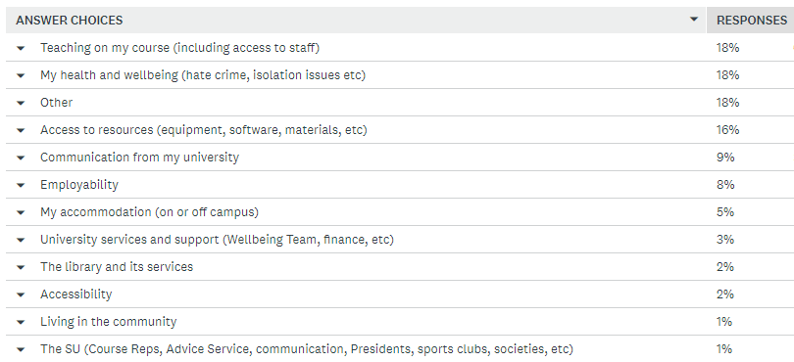
This is currently the top thing on my mind right now
This is the second top thing on my mind right now:
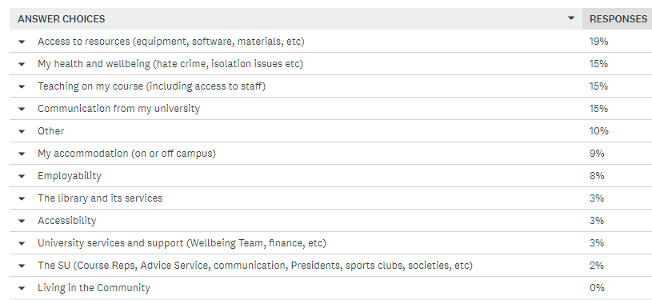

This is the third top thing on my might right now:
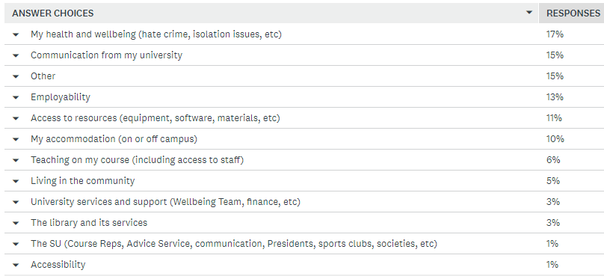

Recommendations

- Students want reassuring communication about the following:

- Safety nets being in place as shown below:
“The lack of a safety net for grades. Usually we have a cross to studio space, many contact hours with 1 on 1 support frequently. Now we are resigned to working in small spaces with simply 2 half hour seminars a week. This means that we are mostly self-taught and I believe that this will negatively impact the results of many students.”
– BA Acting Year 2
- What the plan is for Falmouth University moving forward. Students have stated:
“The University has been very poor at communicating what is going on during the COVID 19 Pandemic. As we share a campus with Exeter University the comparison is so stark. Students were made aware as to the changes made to their course and deadlines whilst Falmouth students a month later are still waiting for clarity. This is unacceptable.”
- BA Press and Ed Year 2
- More access to online counselling and more signposting for it.

- International students want support with accommodation problems, an understanding of time differences by staff and its implications on completing work, and access to financial support.

- Many students requested extensions to deadlines due to all the changes in working patterns. Examples for evidence:
“Have some on course concern. As it's my final year of study I'm worried I won't get the best grade with the anxieties of the pandemic as deadlines still stand to be 1st of May. For our final project, there have been introduced a lot of new things we haven't done before like FF&E packs. It's a lot of additional stress trying to compose something new.”
– MA Professional Writing

- Employability is a big concern and students want it addressed or at least acknowledged by the university, whether it is support with showcasing their work, getting industry professionals involved or just communicating with third years who may be concerned about employment opportunities such as this student:
“They haven't sent out a single email to third years, which has shocked me. I know it's uncertain territory but some guidance or reassurance would be nice.” – BA Graphic Design Year 3

- More contact time with students from certain departments. An example:
“teaching is really good once you get to actually talk to your tutor. My tutor lives in London and is at uni for two of the days in the week when she comes and does a session with us she either is just ill and doesn’t turn up and we have someone else filling in or she doesn't have enough time to talk to us about our work before she has to rush for the train we have about 4 minutes a week if we are lucky to talk to her. when we email her throughout the week it’s a slow reply back and when we want help or to tell her about our art work, for example me going up to the Polyshow I want some help with my work and when I emailed her she just replied that she didn't know what I was working on as she had been away so much and hadn't seen my work in over 5 weeks - that meant I had no help and basically had to tutor myself all year. follow up on tutors and see if every student is getting the full benefit from having one. Another point is that we don't have enough information with closing down and all teams and online teaching just doesn't work we get 1/2 lectures a week from having 6 a week to barely 1 or 2 is outrageous we pay money and then get nothing out of it.”
– BA Fine Art Year 2

