Mature Students Feedback

Week beginning 30th of March

Falmouth University (Falmouth and Penryn Campus) | 86 students
Falmouth Flexible | 3 students
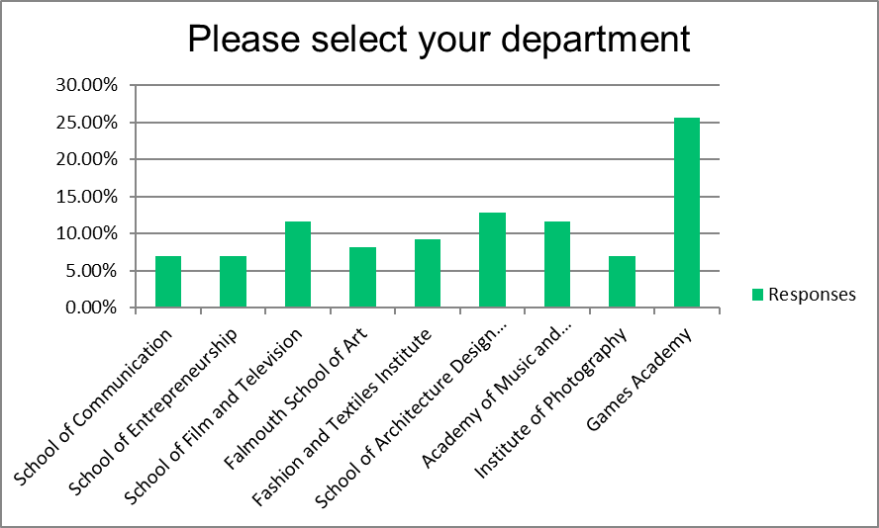
First Year (undergraduate) | 26
Second Year (undergraduate) | 17
Placement Year | 0
Final Year (undergraduate) | 29
Postgraduate Taught | 12
Postgraduate Research | 2
Total | 86
Skipped | 3

Mature Students
The top 3 things on Mature Student’s minds:
- My health and wellbeing (hate crime, isolation issues etc) (28)
- Access to resources (equipment, software, materials, etc)(20)
- Access to resources (equipment, software, materials, etc) (20)
Mature Students were most positive about:
- Teaching on my course (including access to staff) (65%)
- My accommodation (on or off campus) (59%)
- The library and its services AND Communication from my university (53%)
Mature Students were most negative about:
- Employability (43%)
- Assessment methods (39%)
- Access to resources (equipment, software, materials, etc) (35%)
Closely followed by Communication from my university (32%)

Concerns from Falmouth Mature Students
The majority of mature students mentioned concerns about their health and wellbeing and their ability to complete their work satisfactorily.
Health and Wellbeing:
Many mature students said they were anxious and depressed and concerned for the health (due to Covid-19) or their mental health (due to isolation and lack of support). One student mentioned suicidal thoughts, another mentioned losing weight and muscle deterioration and several mentioned lack of motivation and self-care. Several students said they were anxious about their future and what happens next.
Finances and employability:
Finances seem to be a big concern for Falmouth Mature Students. Some have lost jobs that supported their living/studying. Some students have said their online experience does not reflect what they’re paying for the fees. And many students are concerned about how the coronavirus will affect their employability and earnings after their degree.
Accommodation:
Many students are concerned about their accommodation and the cost whilst they are not there. Others are concerned because they’ve left a small amount of belongings and don’t know if this means they’ll be charged for accommodation.
Several students are accommodated in halls but are concerned what happens after their contracts finish as they have nowhere to go: One student has said they
‘Need to be out by the end of June, now all the agencies are shut before we’ve found somewhere’.
And another said:
‘I don’t have a house or a job and have been praying every day that student accommodation doesn’t kick me out as I will become homeless.’
Completing their work at home:
Many students mentioned the difficulty of moving onto online working due to lack of resources and equipment, studio space, lack of equipment or sufficient internet, difficulty of collaboration with other students, productivity and motivation. Some students can’t access their work and others, others talk about lack of access to staff advice and teaching. One student said: “I wouldn't have paid all this money, moving here, fees, rent, lost earnings to do what is essentially an on line course.”
A large part of the feedback was also about concerns over their assessments and grades and their ability to finish their work adequately.
The following quote sums up a lot of mature student feedback:
“Whilst I am grateful for the efforts made by the University and staff to move the course online, as a final year student, the reality of the situation is bleak and making me very anxious. It is not as simple as just moving to online teaching. The pandemic has been extremely distracting to me finishing the course to the best of my abilities and also the impact of not being able to access the studio facilities etc. because of it.”
Other concerns which echo other students that are not mature are:
- No graduation
- Employability concerns
- Communication and clarity over assessment

Recommendations
Student recommendations for the University:
- More regular communication and support
- Tutors to take into account work from first term when assessing
- Look into the wifi in student halls as it’s insufficient for the amount of people trying to do online learning.
- It would be useful to be able to access portable equipment throughout this time. It could be done via courier and insurance policies. It would be little different to borrowing from the University, expect by remote.
- No Detriment Policy so that students will still receive a grade that reflects their time at Falmouth
- More advice please for the research community. Most of what is being communicated is relevant to undergraduates but many researchers are now in a very difficult position, unable to carry out their research, unsure about funding and uncertain about the timescale for submission and examination. Many are also mature students with family and caring responsibilities. We need bespoke advice please and information about funding extensions which are being hinted at by AHRC and other funders.
- Would be nice (as a first year) to have assessments forgotten about and more focus on working together creatively.
Student recommendations for the Student Union:
- Additional support in financial wellbeing, including resources and help opportunities outside university's scope.
- Support with student accommodation
- More support in student/tutor forums when issues come up

