Guide to completing a reimbursement or payment via the SU website
(using SGF- Student Group Finance)

- Log into the SU website thesu.org.uk with your student login details.
- Access your club or society page via the cog in the top right-hand corner.
- Select ‘Finance Requests’ on your admin dashboard.

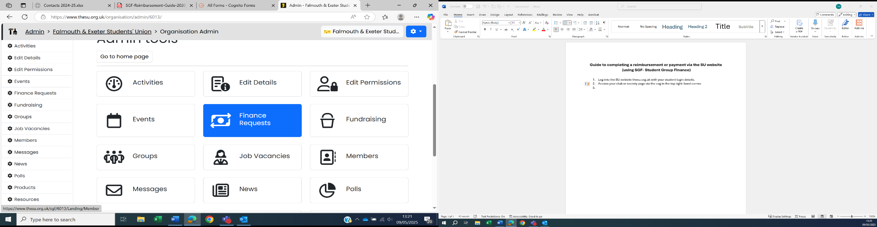
- Select Money Request to access the SGF platform and arrange a reimbursement or a payment.

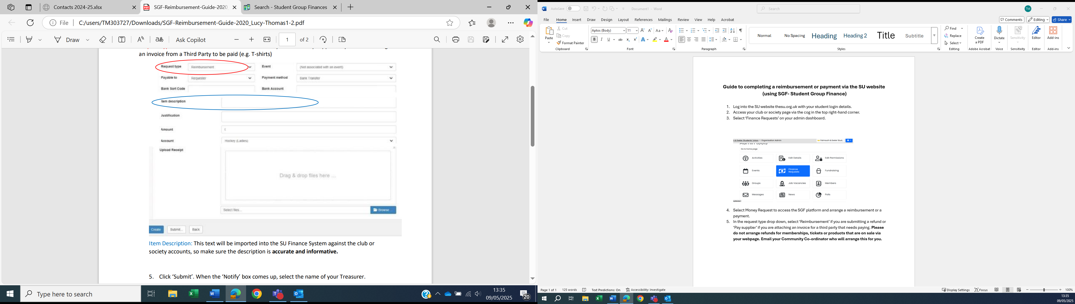

- In the request type drop down, select ‘Reimbursement’ if you are submitting a refund.
Select ‘Pay supplier’ if you are attaching an invoice for a third party that needs paying. Please do not arrange refunds for memberships, tickets or products that are on sale via your webpage. Email your Community Co-ordinator who will arrange this for you.
- As only group committee members have access to SGF, you can also arrange a reimbursement for another group member by selecting ‘other student’ under payable to.

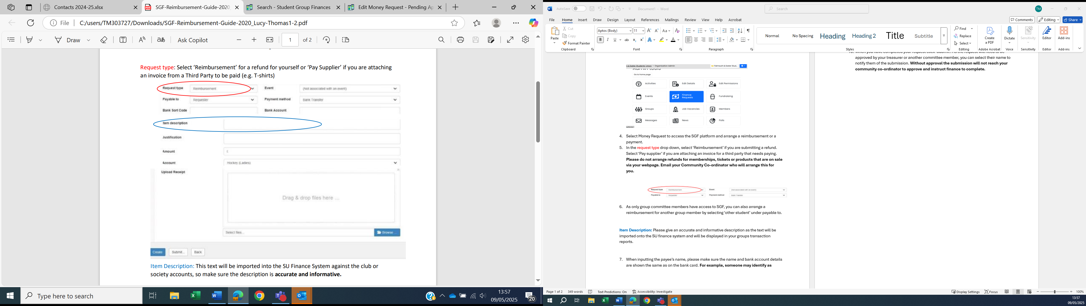

Item Description: Please give an accurate and informative description as the text will be imported onto the SU finance system and will be displayed in your groups transaction reports.

- When inputting the payee’s name, please make sure the name and bank account details are shown the same as on the bank card. For example, someone may identify as Dave, but David could be registered on the bank account. This needs to be correct or the request will be denied.
- If you are submitting an invoice to complete payment, the supplier’s bank account details will be on the invoice itself.
- Receipts or payment confirmations will need to be kept and uploaded to a submission as a proof of payment. Receipts for fuel are not accepted as a travel reimbursement. You will need to complete a travel reimbursement form and submit it to SGF.
- When you have completed your request click ‘Submit’. As the request will need to be approved by your treasurer or another committee member, you can select their name to notify them of the submission. Without approval the submission will not reach your community co-ordinator to approve and instruct finance to complete.
- The person notified of a request will receive an email with the subject ‘Request to Action in SGF’. On your dashboard you will see a list of requests and their status. You will need to ‘Approve’ a request if you are happy for it to be paid. If you need more evidence or justification, you can ‘Refer to Requestor’ or if you do not want to refund the student you will select ‘Reject’.

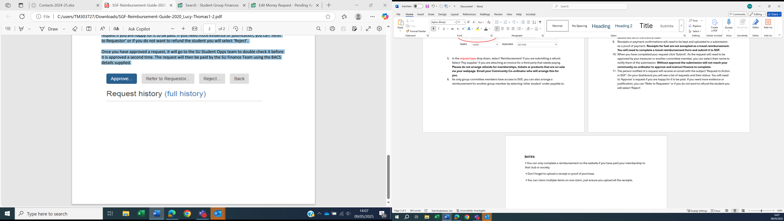
NOTES:
• You can only complete a reimbursement on the website if you have paid your membership to that club or society.
• Don’t forget to upload a receipt or proof of purchase.
• You can claim multiple items on one claim, just ensure you upload all the receipts.



