HOW TO…
Utilise social media and digital resources effectively

A guide to:
- Using your page on the SU website
- Promoting your group online
- Using social media channels effectively
- Top tips

Using your group's page on the SU website
For both old and new students, the SU website is often the first port of call for individuals to find out information about your group.
The page has seven editable tabs for you to use to give potential members a real insight into your group, they are:
- About – this usually consists of a couple of paragraphs about your group and it is nice to include a couple of images to help make your group feel friendly and approachable
- Committee – this details the roles on the committee and holds an email address to allow potential members to contact you with any questions
- News – this is where you can keep students updated on events and projects that your group has been working on and you can link to articles from news outlets if your group has achieved something really special
- Events – here you can detail upcoming events with dates, times and locations
- Elections – this is where you can manage a committee election during the handover period in March/April
- Meetings – if your group holds regular meetings or training sessions this is a good place to detail them and it is also worth mentioning whether new members can pop along to a session
- Polls – this is a useful tool for holding polls for your members to vote on. This can be used for decisions such as choosing your adopt a charity
To edit the information on your page on the SU website, follow the instructions below:
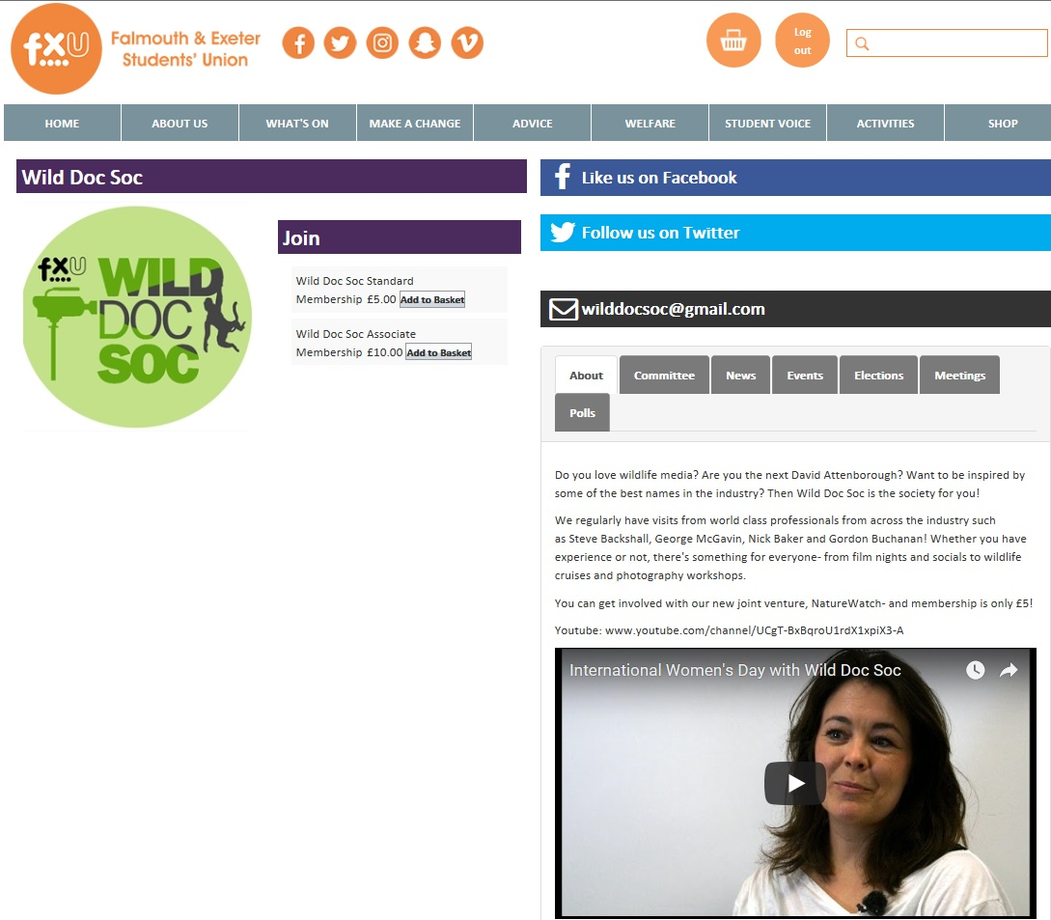
The above is a screenshot of what visitors see when they arrive on your page (please note that it is now re-branded The SU but the page layout is still the same). It’s important that you upload a square logo, link up your social media accounts and include a contact email which is accessed regularly.
The ‘about’ section on your page is key: this is where you sell yourselves. Provide a summary of your activities and the benefits of getting involved. You can embed a video of a recent event or training session to give a more personal approach.
Your group’s key information can be edited via ‘admin tools’ (see below)
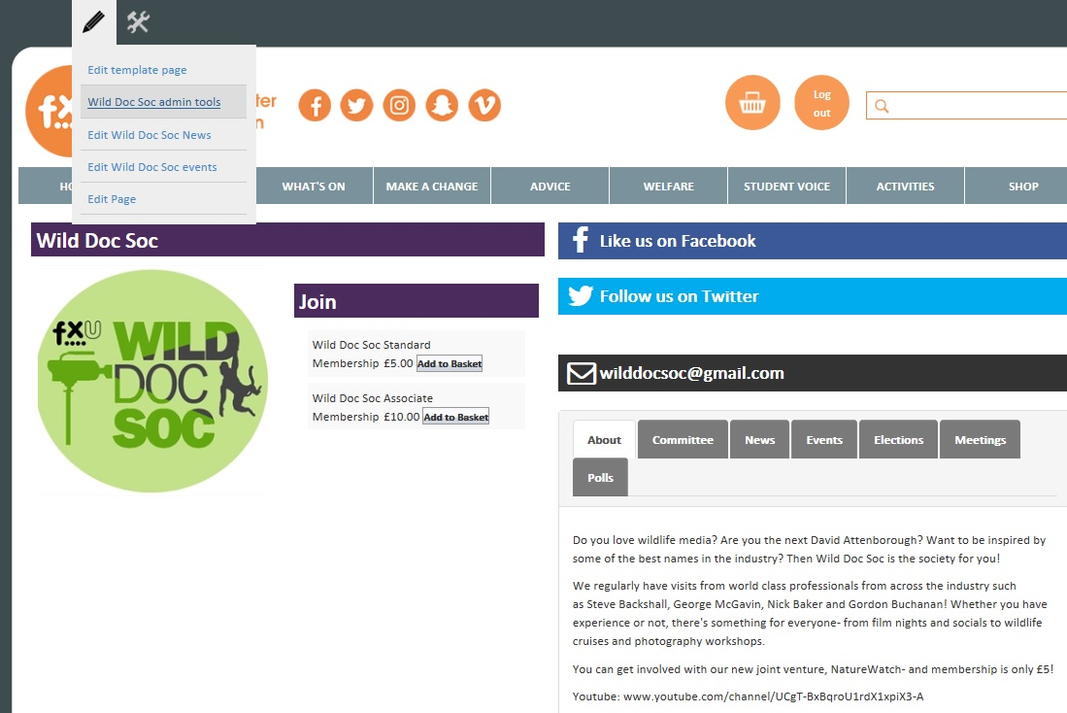
‘Edit details’ is where your key landing page info sits
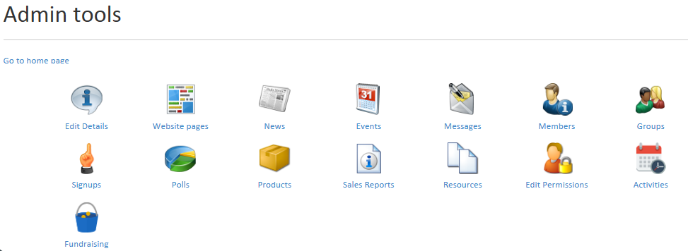
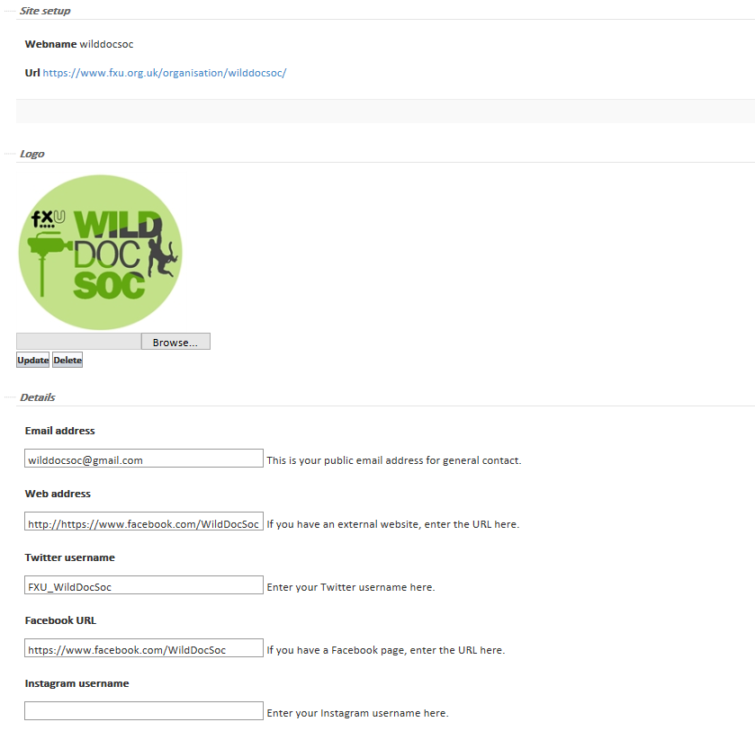
You can also create events, news stories, polls and message your members directly, as well as look at sales reports for products, e.g. tickets sold, merch ordered, etc.

Promoting your group online
Effective digital marketing is really important as it can help you attract new members, sell event tickets and share positive news stories about your group.
Digital marketing can come in many forms, from using your group's page on the SU website, to writing articles for campus news outlets, such as the Falmouth Anchor or TruthFal, to setting up Facebook groups/pages, Instagram and Twitter accounts.

SU Media Channels
For large events you can use SU's own media channels for marketing your group. Methods include using the digital media screens dotted around the campuses, having an image with a hyperlink on the scrolling banner on the homepage of the SU website and having a link with an image in the regular SU newsletter. To have your marketing materials featured, email Emma Farley (emma.farley@thesu.org.uk). Dimensions for each of these three marketing strategies are listed below:
- Media screens: Make sure to include key info, your group's logo and a way to find out more info! The dimensions are: 1920 (width) x 1080 (height) in pixels.
- SU Newsletter: Remember to include the link to an external site such as to your group's page on the SU website where you can buy tickets, or to a Facebook event or press release. The dimensions are 600 (width) x 160 (height) in pixels.
- SU Website Banner: These are banners are on the homepage of the SU website. The dimensions are 1156 (width) x 300 (height) in pixels
Student Media & Press Releases
Student media organisations such as TruthFal and the Falmouth Anchor often report on positive news stories of the SU groups if you can think of a good angle – e.g. raising money for a particular charity or attempting something new.
The Falmouth Anchor also runs weekly round-ups where sport teams and societies can advertise events/matches/results and general updates. To be included you can email some images (along with credits) and a paragraph on the event to editor@falmouth-anchor.co.uk

Facebook
Facebook is a useful resource for SU Activity groups as it is the most commonly used social media platform. It is worth setting up a page or group for your activity group so that you can post upcoming events and information for members to access. You can also advertise committee elections and ask your membership for opinions on decisions.

Instagram
Instagram is another useful social media channel for your group to utilise. It’s very useful for creating a level of approachability and can engage new members effectively. Before Freshers it is worth building up the account with content to make it seem active and interesting.
If you would like to be featured on The SU's Instagram account for a particular event/match, get in touch with the SU President Student Experience (sarah.redman@thesu.org.uk)

Twitter
Twitter is the least used social media platform by students but is useful for engaging external stakeholders, such as businesses which may be interested in sponsorship, the two universities, NUS or sabbatical officers around the country.
A note on social media: It is best to do one thing well rather than try and spread yourself too thinly and be inconsistent. If you’re an outdoorsy group, you may find that Instagram works better for you. If you like to have a lot of discussions with other groups, Twitter may work better. With Facebook, we recommend having a public-facing page rather than a group (closed groups work well for committee members).

Make sure you like/follow the SU social media accounts. Drop us a message if you’d like anything shared.
www.facebook.com/TheSUFALEXE
www.twitter.com/TheSUFALEXE
www.instagram.com/TheSUFALEXE

email: emma.farley@thesu.org.uk

For maximum exposure, tag external groups, such as BUCS for sporting competitions and NUS for campaigns. Also make use of trending hashtags, such as #MondayMotivation You never know who might see your post.

Which brings us to… be nice! Students have been known to be sued for defamatory tweets, so keep it clean and legal.

Top Tips

Group Chats
- Do: create committee group chats to keep the team up-to-date and make decisions to keep your group running smoothly.
- Don't: forget that these committee group chats are representing SU and the two universities and therefore conversations must adhere to the SU Code of Conduct

