How to ….. be a Publicity Officer

This guide is to help you identify the key roles and responsibilities of your committee. In order to have a successful committee, it is important that you understand what is expected of your role. Some groups may operate with different roles and this list below is not exhaustive. Smaller committees will have some of these roles amalgamated, so it is up to your committee to decide on responsibilities for your activity group. As a committee, it is your joint responsibility to ensure that the activity group runs smoothly, so be aware of what your fellow committee members are doing and help out where necessary.

Publicity/Marketing/Social Media/Merchandise Officer
Groups communicate primarily through email, social networking sites and the group’s SU web pages. Every group needs publicity – from dinners to hoodies to fundraisers to tours. It’s a great way to recruit members, network with other activity groups, organise a huge and exciting event and generally create a buzz around your club.
Key responsibilities:
- Ensuring social media is kept up to date with information
- Sharing photos and videos of event activities
- Updating results and news on group pages
- Advertising events
- Helping to arrange ordering of kit/merchandise

The SU website
Each activity group has their own page on the SU website. It is essential that this is kept up-to-date and is as engaging as possible. The directory page on the website is consistently the most viewed, providing valuable information to FE students thinking about where to apply and Freshers, both pre- and post-arrival.
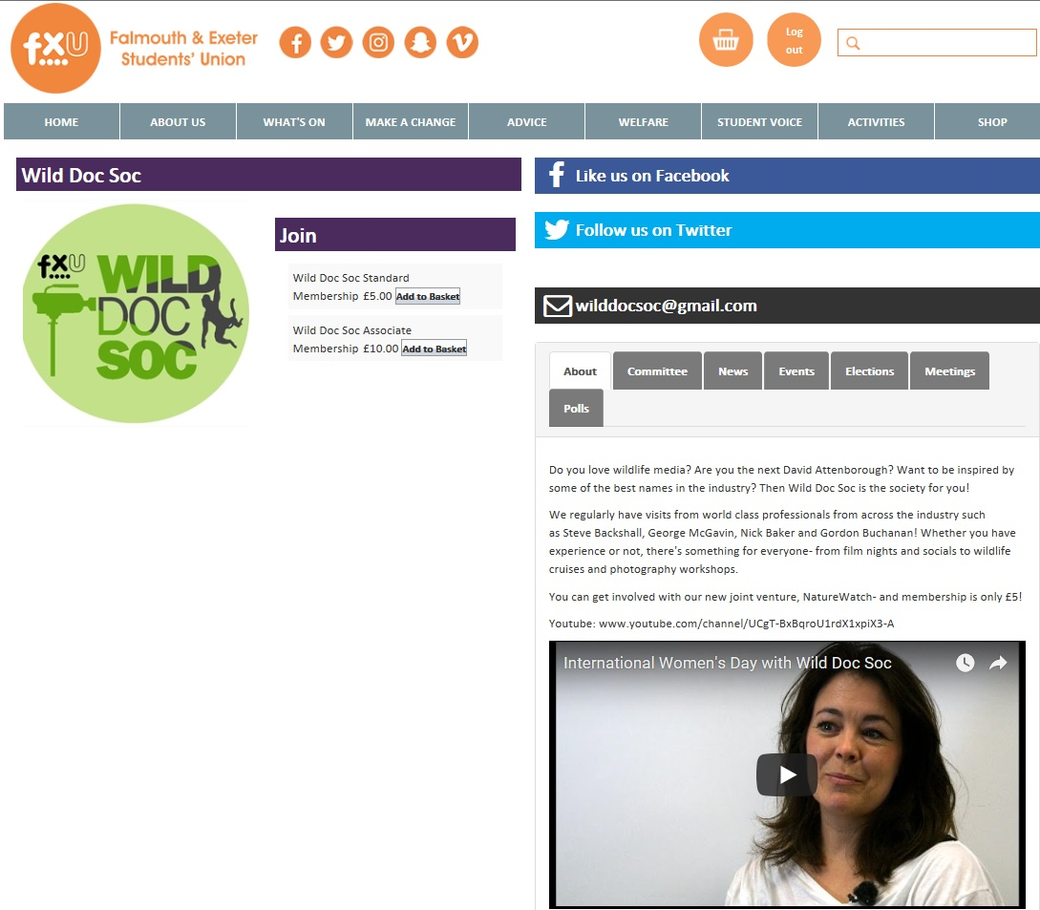
The above is a screenshot of what visitors see when they arrive on your page. It’s important that you upload a square logo, link up your social media accounts and include a contact email which is accessed regularly.
The ‘about’ section on your page is key: this is where you sell yourselves. Provide a summary of your activities and the benefits of getting involved. You can embed a video of a recent event or training session to give a more personal approach.
Your group’s key information can be edited via ‘admin tools’ (see below)
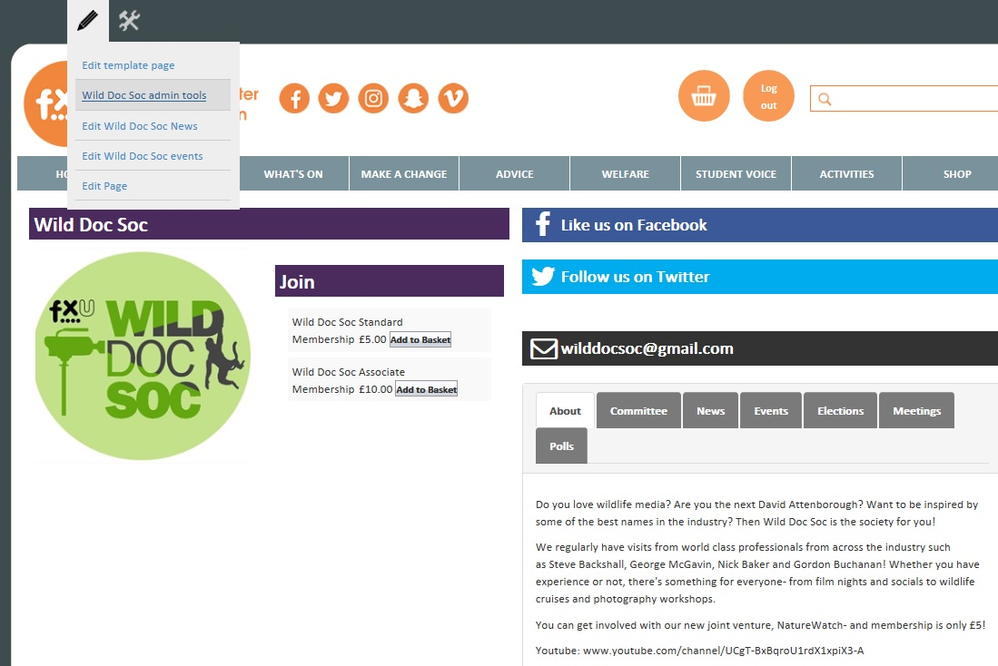
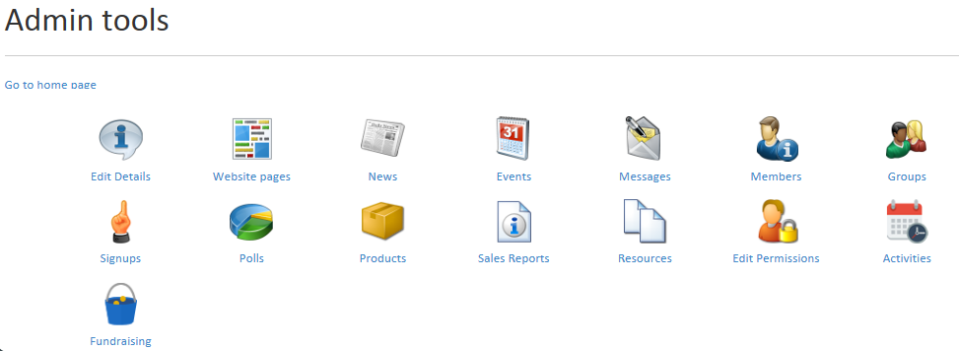
‘Edit details’ is where your key landing page info sits
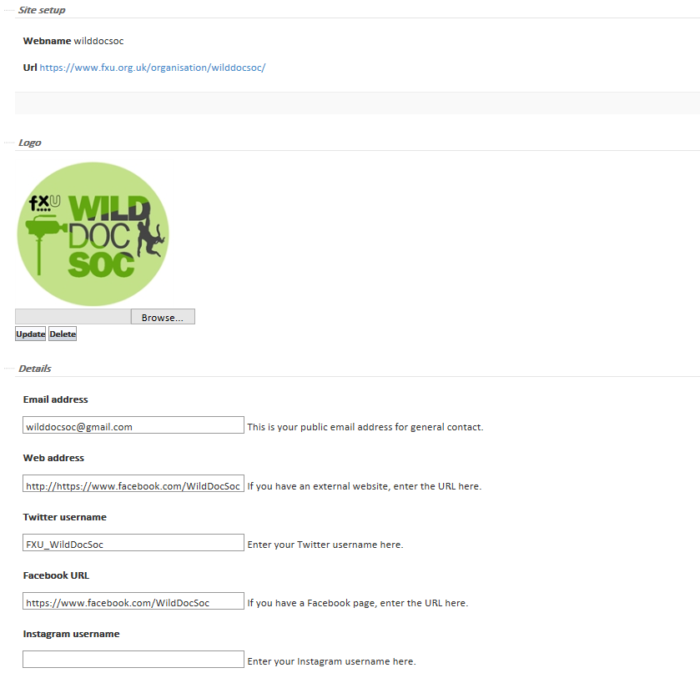
You can also create events, news stories, polls and message your members directly, as well as look at sales reports for products, e.g. tickets sold, merch ordered, etc.
You can also advertise on the SU website beyond your group’s page. Large-scale events and campaigns can be highlighted on the homepage via our banner ads and/or quick links. It is up to your publicity team to create the appropriately sized graphic but the SU Marketing Team can schedule the ad in for you. The dimensions for the banners are 1156 (width) x 300 (height) in pixels
Social media
It’s best to do one thing well rather than try and spread yourself too thinly and be inconsistent. If you’re an outdoorsy group, you may find that Instagram works better for you. If you like to have a lot of discussions with other groups, Twitter may work better. With Facebook, we recommend having a public-facing page rather than a group (closed groups work well for committee members).
Make sure you like/follow the SU social media accounts. @ us for RTs and drop us a message if you’d like anything shared.
www.facebook.com/FXUnion
www.facebook.com/FXUActivities
www.twitter.com/FXUtweet
www.twitter.com/FXUActivities
www.instagram.com/fxu_insta
email: emma.farley@fxu.org.uk
For maximum exposure, tag external groups, such as BUCS for sporting competitions and NUS for campaigns. Also make use of trending hashtags, such as #MondayMotivation You never know who might see your post.
Which brings us to… be nice! Students have been known to be sued for defamatory tweets, so keep it clean and legal.
Other SU advertising platforms
- Media screens
If your team creates an appropriately sized JPEG, we can circulate this across campus for you, for display in The Compass, AMATA, Sports Centre, Stannary Bar and more. Make sure to include key info, your group's logo and a way to find out more info. The dimensions are: 1920 (width) x 1080 (height) in pixels.
- E-newsletter
We circulate an e-newsletter every week during term-time. It’s image-focused, so if you supply a JPEG and link to more information, we can include this on a first-come-first-served basis. Obviously, if every group were to include a message every week, it would become a very long newsletter! Remember to include the link to an external site such as to your group's page on the SU website where you can buy tickets, or to a Facebook event or press release. The dimensions are 600 (width) x 160 (height) in pixels.
- The Falmouth Anchor
The Anchor also provides regular updates from SU activity groups. Be sure to get in touch to have your news/campaign highlighted

Press releases
We love sharing good news stories with the wider community. If you’ve raised loads of money, competed in a national competition or done something to contribute positively to the local community, we want to hear from you! Contact Emma to discuss a press release, which will need direct quotes from students involved and print-quality photographs. Bear this in mind ahead of your event as it may be that this can be drafted ahead of the event so it can be sent more immediately. Time is of the essence!
Media library
We’re always looking to grow our media library and so any photos/videos you have of your activities are of huge value. Do forward anything to Emma as we’re always looking for imagery for Open Day and Freshers docs, as well as end of year videos, etc.

