
Election Guidance

What is an Election?
An Election is:
- A process to elect your new committee for the next academic year
- You can announce your election results at your AGM if you are not changing committee roles or this can be done afterwards.

Why have an Election?
The Students’ Union is a democratic organisation, and it relies on your group to be just as democratic, so that every student has a fair chance of being involved.
If a group doesn’t hold an election during the set election period via their webpage, the group will be placed on the adopted list for the following academic year.

Steps on how to set up an election
Activity group committee members will have access to manage their elections via their student account on the SU website.
We understand that every Activity Group is unique with different needs, and some will see more benefits than others from running an election online, however we believe that all groups will benefit from the following from using the online system:
- Better accessibility for members
- Increased turnout
- Improved transparency
- Less paperwork

2026 Elections schedule
The system provider will be counting the results for all SU clubs and societies altogether, so it is important that all SU clubs and societies keep to the election schedule. Please set up your election at least two weeks in advance of nominations opening, so your community co-ordinator can check if any elections are outstanding. Please avoid setting up your election last minute and keep to the dates below:
Set up elections | Start from Monday 16th February
Nominations open | Monday 16th March 0:00
Nominations close | Monday 23rd March 0:00
Voting Opens | Tuesday 24th March 0:00
Voting Closes | Tuesday 31st March 0:00
Results announced | Monday 6th April

Step 1 - Setting up your election online
- Committee members will need to make sure they are logged onto the SU website, click on the tool icon (top right), and elections admin/edit elections link.
- Under Organisation you will need to select your group (you should only be able to select this)
- Click “Create New Election”
- As part of the set up process, you'll need to have decided when you want nominations to open and close, and when you want voting to start and end.

Step 2 - Details
- Title - *Activity Group name* Committee Elections *Date* E.g. Singing Society Committee Election 2026
- Display on Website – this must at the very least cover the date when nominations open and when voting closes.
- Description - this is optional! You can include a brief description of the election and the positions available if you wish.

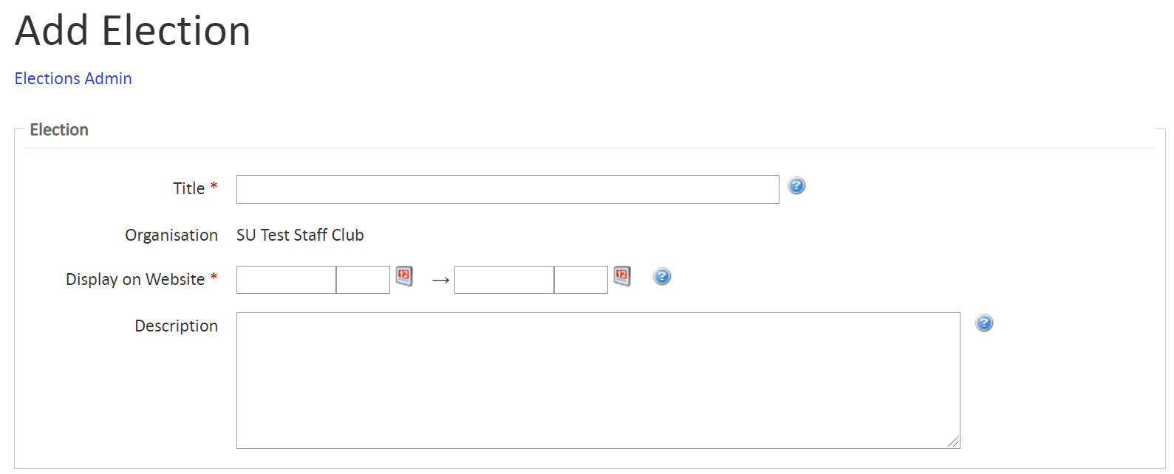

Step 3 – Nominations
- Nominations period - this is the period when members of your Activity Group can nominate themselves for a position. Please keep to nominations scheduled 16th to 23rd March.
- Online/ Paper manifesto Deadline – Select same time as nomination end time.
- Deposit amount – Ignore/leave blank
- Allow Slates – Ignore/leave blank
- Max number of candidacies – Ignore/leave blank
- Candidate T&Cs: Add something along the lines of ‘Must be a paid member to run for election’

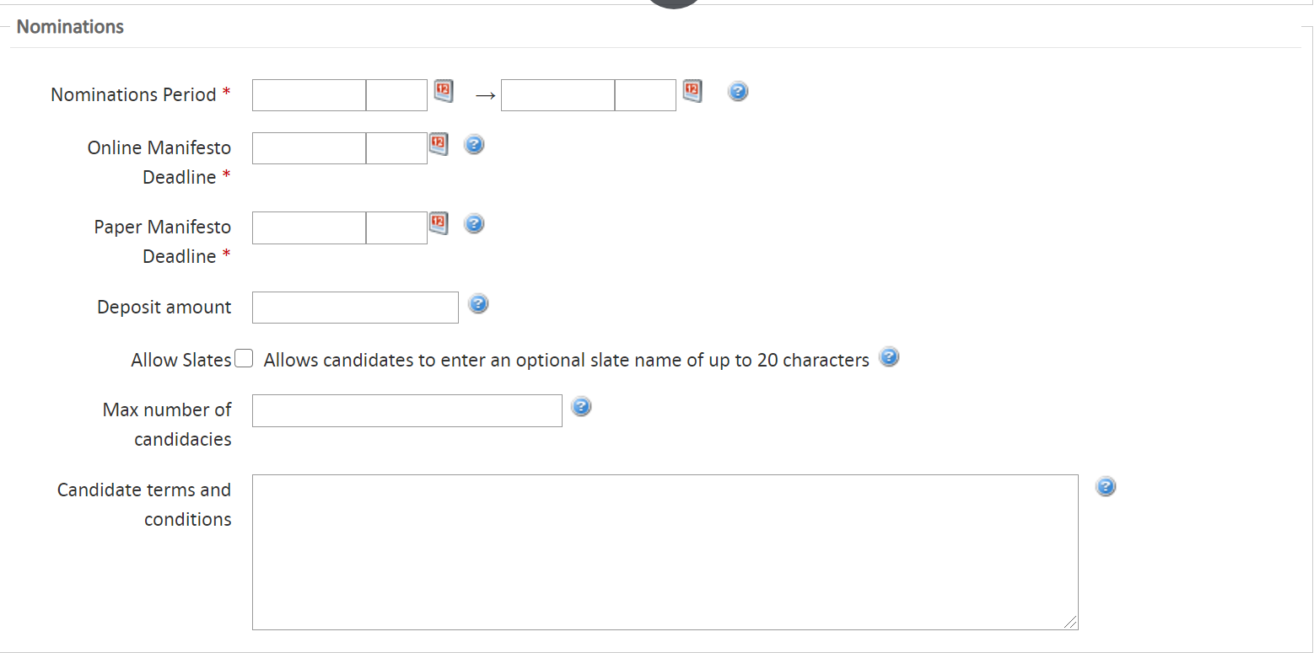

Step 4 - Visibility
- Non-logged in users - Select 'Basic'
- Logged in users - Select 'Full Members Only'
- Not Eligible message - 'Sorry you are not eligible to nominate yourself for this position as you are not a standard member of the ‘Activity Group’

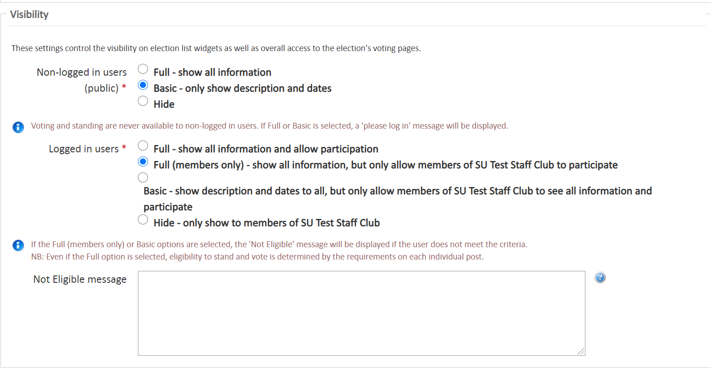

Step 5 – Image, Profile Page & Filter posts lists
- Image – optional and not required
- Profile Page - Help text box - leave blank
- Filter Posts Lists – leave blank
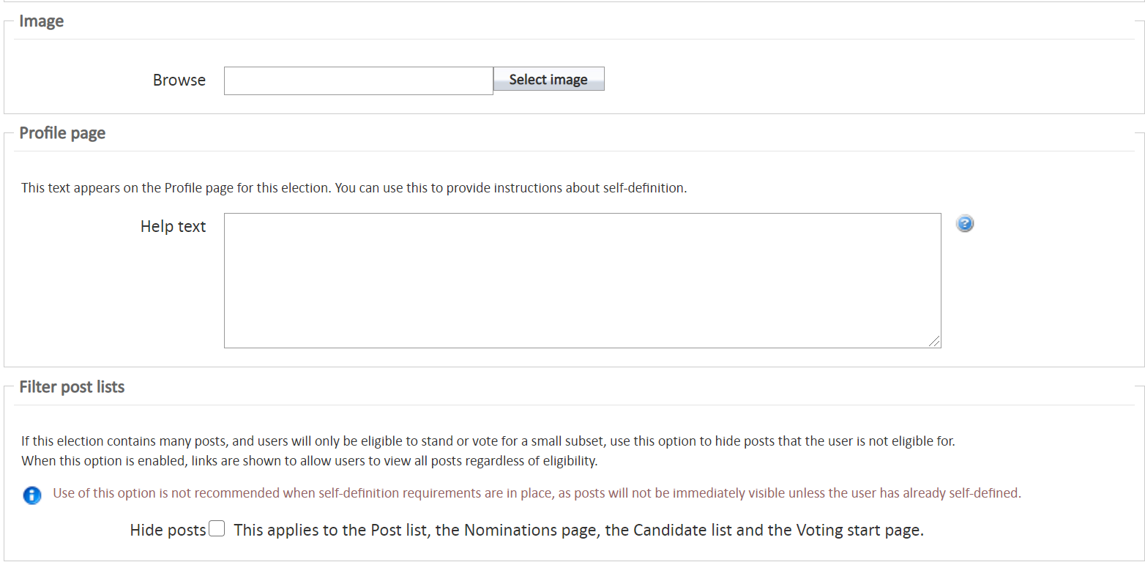

Step 6 – Polling/Voting
- The only field you need to complete of the three voting options is e-voting. You'll need to select a date after nominations have closed to open voting and a date for voting to end. Please keep to the scheduled dates 24th to 31st March.
- Voters T&Cs – Add something along the lines of ‘Must be a standard member to vote’
- Abstention confirmation text - 'This is to confirm you have abstained from voting for this position.'
- Voting Completion Text - 'Thank you for submitting your vote.'
- After completing this select 'Save Election'.
Default Ballot Rubric – leave as default.
Tip - If you have made any errors on these first 6 steps – the site will show an error message as to why this election hasn’t saved. Make sure when adding dates – you follow the website format or use the calendar icon and times are in a 24 hour clock e.g. 23:00. If it is not in this correct format it will come up as an error.
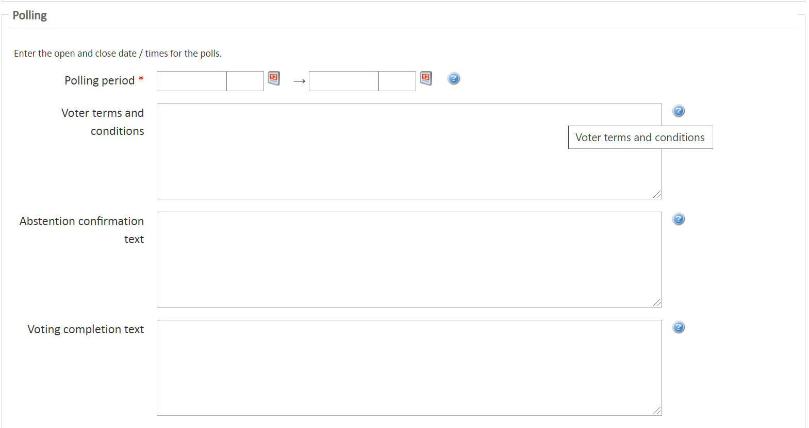
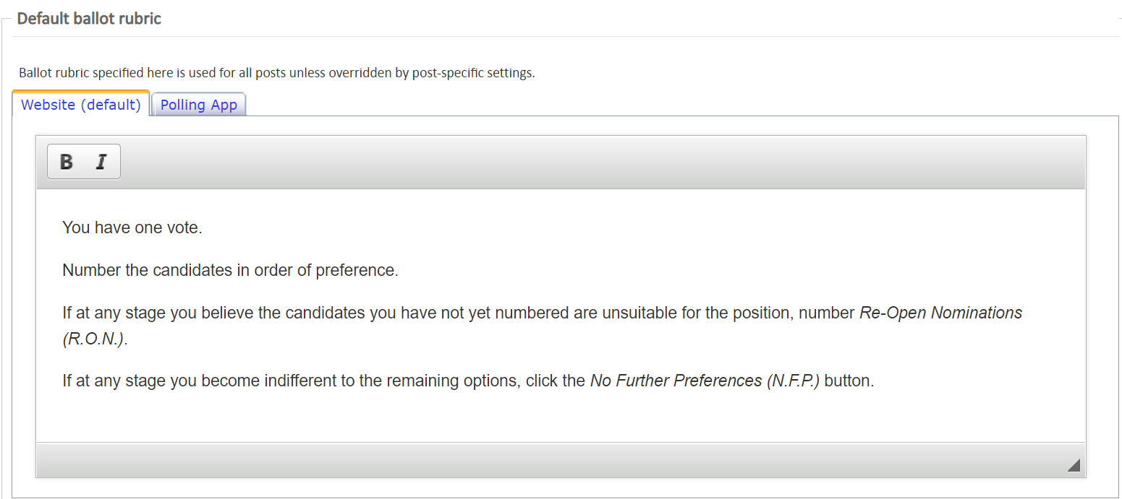

Step 7 - Adding Posts
- Reselect the election then go to the 'Posts' tab at the top.

- For each post you want to add click 'Add post' and complete the following:
- In the Group box you need to write the post name. Start typing your group name then the post e.g. ‘Netball Treasurer’
- You will see any posts you have within your group shown in a list, individually you will need to add these.
- If you would like to add a new post (which is a new role that you haven’t had previously) please email your coordinator so they can set them up for you, they will then appear in the list.
- Short description - Here you can put a description of the post and the role responsibilities if you wish.
- Places - number of places available for this post (usually this is 1)
- Quorum – Leave blank
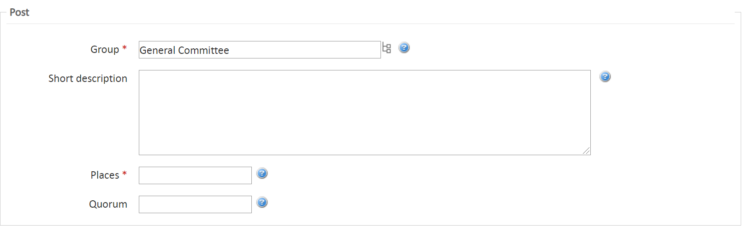
- Options – Show organisation name – if you tick this box the post will include your group name e.g. ‘Netball Treasurer’ rather than just Treasurer
- Number of proposers required - leave blank
- Make sure 'Use RON Candidate' is selected
- Manifesto Options - Make sure 'Allow Manifesto text' is selected. You can also add a word count if you wish! The 'Allow Photo' and 'Allow Slogan' are optional!
- Then select 'Save Post'!
- Repeat this process of step 7 for however many posts you want to include in your election.
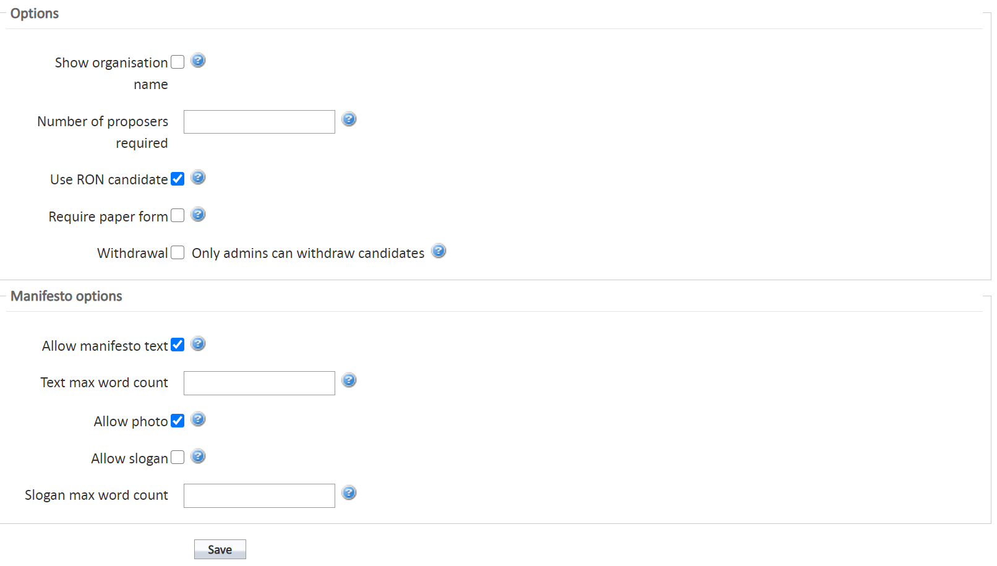

Step 8 – Candidates
Once your candidates have nominated themselves you can check them under the ‘Candidates’ tab.

In order for voting to open approval status must be set to Approved, please speak to your coordinator if you have any problems ensuring the candidates are all approved. If candidates are not approved then voting will not begin!
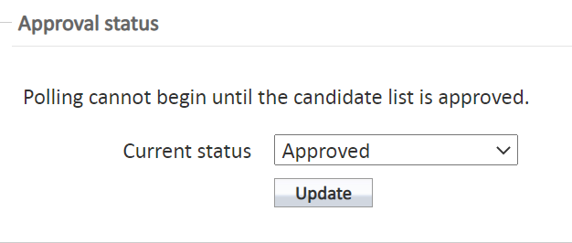

Step 9 – The Results!
The results are set to be counted by the system provider MSL once voting closes on 31st March and these will be emailed to the President and secretary (or equivalent) of your activity group by Monday 6th April.

CHECKLIST…
Quick tick list to ensure you have covered everything needed to run a successful Election!

Things To Do | Checked
Look at current constitution and committee structure to see if you need to make changes at AGM
Discuss with the committee what positions are available (if this was amended at your AGM then this will need to be communicated to your Coordinator)
A Committee member will need to add and manage your group elections (please see step 3)
Email out via your page to members with information on the positions and dates available to nominate
Promote when elections and voting is live to encourage as many members as possible to vote via email to all members

Guiding principles

All candidates are expected to comply with the following guiding principles:
- candidates must treat other candidates, students and members of the public with respect.
- candidates must respect the campus environment and the local area they live in.
- candidates will not act in such a way as to bring the elections process, the Union or the University into disrepute.
- candidates’ campaigns should be fully transparent and accountable to the Union.
- candidates must not do anything to gain an unfair advantage.
- candidates must not undermine the fair and democratic running of elections.
- candidates must not seek sponsorship for this election.
- candidates must not use electronic devices when soliciting votes and voters should vote on their own devices.
- candidates must not break any general union and University/College rules and regulations. This also includes the Law

FAQs

When do we need to have an election?
An election should take place by the end of the Spring Term (by Easter).

Who can run for election?
Any paid standard member of your activity group can stand for any of your activity group committee positions. A standard member is defined as a current student of Falmouth University or University of Exeter. *If you feel your committee positions require specialist skills then please contact your coordinator to discuss this further*

Who can vote in an election?
Any paid standard member of your activity group can vote for each position being contested.

How long should an election voting be open for?
On average most groups allow 1 week for their members to vote.

How do nominations work?
The candidates interested in standing for any position can do so via your group page. They will need to click on the election tab which will give information on the election dates/times according to what you set for your group. Those candidates can submit a manifesto to support their nomination.

What is a manifesto?
A manifesto tells people why you want to represent them and why they should vote for you; it sets out your ideas and plans. Essentially your manifesto needs to say WHY you think you would be a good, elected representative and WHAT you would do if you were elected. The manifesto word limit is 400 words. You can only have words in your manifesto box on our website, but you can embed links to your Facebook campaign, videos, posters / PDFs, pictures etc. This will open a new tab with this extra information, they will only see text in the manifesto box on our website. Please make sure this info is passed onto your members, so they understand what is involved if they wish to stand for election.

Who is R.O.N.?
R.O.N stands for Re-Open Nominations.
All Union elections give the option for voters to express their wish that nominations for a role should be re-opened. Voting for this option is usually taken when voters do not feel as though any of the candidates offer viable or credible policies. Should RON win an election at the SU, either the post would not be filled, or an election would be held again.

How do you find out who has been elected into a position?
These will be sent directly to your groups President and secretary on Monday 6th April.

Any questions?

Please contact your Coordinator or email activities@thesu.org.uk

